MSc Project Report

School of Physics, Engineering and Computer Science  
University of Hertfordshire

**Design of a MIMO System for Wireless LAN application**

Report by

Deep Kumar Mada

Supervisor

Dr. Qi Luo

Date

10/05/2021

# DECLARATION STATEMENT

I certify that the work submitted is my own and that any material derived or quoted from the published or unpublished work of other persons has been duly acknowledged (ref. UPR AS14 Appendix III - version 14.1, sections 2 to 2.9– Section on cheating and plagiarism)

Student Full Name: Deep Kumar Mada

Student Registration Number: 19024718

Signed (electronically or pasting signature image) …. Deep Kumar Mada…

Date: 10/05/2021

# ABSTRACT

This thesis on the study of MIMO system in Wireless LAN, MIMO is originated from Wireless Communication and Antenna system. There are four technologies used to transfer and communicate information is SIMO, MISO, SISO, MIMO. MIMO is to deliver data speeds, low latency, more reliability, Massive network capacity support, short communication, especially in (IOT) internet of things. The advantages of MIMO systems are producing high data speed and reduce latency. MIMO is used to improve the antenna bandwidth to support huge number of users. The new structure of the MIMO antenna producing better Mutual Coupling (MC) performance and its separation is very closely. In MIMO more antennas could be located with the compact size. The MIMO function is used for single application or multiple application due to the wideband frequency coverage.

Mutual Coupling (MC) is an electromagnetic phenomenon which exist in various antenna arrays and it usually determined the antenna operation. The impacts of MC on array antennas stretches over many various regions and its uses of employment in uncertain area is MIMO, sonar, diversity system and radar system. Furthermore, this thesis mainly demonstrates the proper modelling and inclusion of physical antennas, performances of MIMO system, sum rate of downlink in mutual coupling. In this thesis we also discussed about WLAN antennas, WLAN antenna is to installed on the wireless devices with Access point. This WLAN has certain frequency range if 2.4GHz and 5GHz. Wireless LAN is a computer network which links two or more devices by using wireless communication system. In this WLAN and WIFI is used in same nature for transfer wireless data with high speed.

In this thesis we also discussed about Channel sounding, the channel sounding is a procedure to access the radio signal for wireless communication in MIMO system. In this wireless signal spreads in a different way to estimate the channel sounding and simulate, design the various wireless systems.

Additionally, we discussed about 802.11 ac Multiuser in MIMO precoding by using with communication and WLAN toolbox the results are mention in below of the thesis. The 802.11ac is supports the downlink multiusers to transmits the data in different users like 4x4, 6x6, 8x8, and 16x16 etc...,

**Keywords:** MIMO, WLAN, Mutual coupling, WIFI, Radio signal, Array antennas, Access point, Computer network, Channel sounding.

# ACKNOWLEDGEMENTS

I would like to expand my sincere thanks to my supervisor, Prof, Qi Luo. For his valuable support and supervision. His advice, encouragement, guidance and inspiration have been invaluable over last past four months. I admire his critical eye for important research topics in MIMO system. I still remember that prof. Qi Luo is always kept open mind in each and every academic discussion.

This thesis would not have been completed without prof support and guidance. I have been benefited professionally and personally in this doing thesis.

Furthermore, I would like to thank you for University resources that makes me more deeply to learn in this thesis.

Finally, I wish to thank prof. Qi Luo for encouragement and limit less support for this whole thesis.

# TABLE OF CONTENTS

DECLARATION STATEMENT i

ABSTRACT ii

ACKNOWLEDGEMENTS iii

TABLE OF CONTENTS iv

LIST OF FIGURES v

GLOSSARYS vi

1.1 [MIMO System] 1

1.1.1[Massive MIMO] 1

1.1.2 [MU-MIMO Communication System] 2

1.2. [Massive MIMO with Antennas] 4

1.2.1 [ Research of Antenna Array in MIMO] 5

1.3 [ Sparse Array] 5

2. [Mutual Coupling in Antenna Array] 7

2.1 [ Mutual coupling in Phased Array] 7

2.2 [Mutual coupling and its impact] 8

2.3 [Anaysis of Antenna Array with Mutual coupling ] 10

3. [ IEEE 802.11 Wireless LAN System ] 13

3.1 [ IEEE 802.11 WLAN and its standards] 13

3.2 [IEEE 802.11 WLAN Protocols] 14

3.2.1 [ WLAN and its Configurations ] 15

3.3[ Channel Sounding For MIMO System] 17

3.3.1 [ Channel Sounding data of Tx & Rx signal] 17

3.3.2 [ Precoding in MIMO System] 18

3.3.3 [ Shadowing Effects in MIMO System] 20

4. Results …………….………………………………………………………………………………….23

Conclusion……………………….……………………………………………………………………….27

REFERENCES 28

BIBLIOGRAPHY 30

APPENDICES 31

**List of Figure**

Figure 1.1: yearly development projections of development gadgets………………………………….2

Figure 1.2: Throughput and latency equipment’s uses in 5G………………………………………….3

Figure 1.3: Electromagnetic and information theory based iterative co-design of BSA………………4

Figure: 2.1 Mutual coupling in phased array…………………………………………………………….8

Figure: 2.2 Transmitting and Receiving Mutual coupling antenna………………………………………10

Figure: 2.3 Analysis of antenna array mutual coupling with the numerical simulation software…….11

Table 2.3.1: Computational complexities of several IE based methods………………………………12

Figure: 3.1: IEEE 802.11 Wireless LAN and its Standards……………………………………………….14

Figure: 3.2.1(1): wireless access point (WAP); ………………………………………………………….15

Figure: 3.2.1(2): DSS and client…………………………………………….…………………………….16

Figure: 3.2.1(3): WLAN / Wi-Fi standards………………………………………………………………….17

Figure: 3.2.2: Precoding for Multiple users in MIMO system; Source…………………………………18

Figure: 3.3.1 channel sounding data of transmitter (Tx) and receiver (Rx) signal……………………20

Figure: 3.3 (1): shadowing model with log normal………………………………………………………….21

Figure: 3.3 (2): Shadowing signal level with and without fading channel……………………………….22

Figure: 4.1: 802,11 ac Multiuser MIMO recoding in 6x6 matrix……………………………………….23

Figure: 4.2: 802,11 ac Multiuser MIMO recoding in 8x8 matrix………………………………………24

Figure: 4.3: Bit Error Rate Analysis………………………………………………………………………24

Figure: 4.4: BER with different techniques………………………………………………………………...25

**GLOSSARYS**

MIMO: Multiple Input Multiple Output

LTE: Long Term Evolution

IEEE: Institute of Electrical and Electronics Engineers

TDD: Time Division Duplex

BSA: Base Station Antenna

RF: Radio Frequency

EE: Energy Efficiency

EEP: Embedded Elements Pattern

MC: Mutual Coupling

LAN: Local Area Network

WLAN: Wireless Local Area Network

ELAA: Extremely Large Aperture Array

RCS: Radar Cross section

DOA: Direction of Arrival

EM: Electromagnetic

PDF: Partial differential equation

FEM: Finite Element Method

FDTD: Finite Differential Time Domain

IE: Integral equation

MOM: Methods of Moments

CEM: Computational Electromagnetic Methods

SWE: Spherical Wave Expansion

GSM: Generalized Scattering matrix

EWC: Expansion Wave Concept

AP: Access Point

PHY: Physical Layer

WAP: Wireless Access Point

COMP: Co-ordinated Multipoint

SVD: Singular Value decomposition

SDMA: Space Division Multiplexing Access

MRT: Maximum Ratio Transmission

DPC: Dirty Paper Coding

ZF: Zero Forcing

MS: Mobile Station

BS: Base station

CSI: Channel State information

**Chapter 1**

**1.1 MIMO system**

The recent technology and social economy of upcoming modern society have increasing parallel with the growth of mobile communication systems [1]. MIMO is originated from the wireless technology and furthermore antenna Array by using numerous Transmission (Tx) and Receiver (Rx) antennas. It is also key technology of 5th Generation and it is mainly design to layouts; antennas and it particularly focus on high impedance with low cost. I have legitimate standardizations is LTE, WiMAX, IEEE 802.11, HSPA+.

* + 1. **Massive MIMO:**

In this Massive MIMO is a new technology in wireless communication to access 5th Gen in both sub 6 GHz and mm wave groups. Since it started about 10 years ago, it also advanced from a wild “academic” plan to become the centre of innovation that probably will be used for better future wireless technology. The massive MIMO has a multi user technology that can be provide good service to wireless terminals with high mobility environment and also key equipment is base station which works with many antennas arrays and used to serve many terminals in a same time with frequency resource. Mainly, the “Massive” is a word which refers number of antennas and not in a physical size.

In this antenna array have appealing structure factors in the 2 GHz band and a half-frequency divided rectangular array with 200 double polarized components is about 1.5 x 0.75 meters is large. The Massive MIMO works in TDD mode especially the downlink beamforming is misuses to the uplink-downlink reciprocity of radio propagation. In this process the base station array utilizes channel estimates obtained from uplink pilots sent by the terminals to gain proficiency with the divert in two ways. In this way Massive MIMO totally versatile concerning the quantity of the base station radio link and it also work with autonomously, with no sharing of payload information or channel state data with different cells.

The projection of yearly development of associated devices up to 2023 is sown in below Fig 1.1, and also appearing an expanded presence of machine-to-machine associations [2], normally used in a smart detecting and smart observing application. Furthermore, the quantitative expansion in the quantity of associations is trailed by the high quantity service, Especially the development capability of promising innovation like virtual reality, augmented reality or material internet is connected with the advanced in term of high speed and low latency connection [3-5]. In this clearly shows two ends can be drawn firstly, demand of throughput continuously increases and secondly, the measure of accessible range is restricted [6].

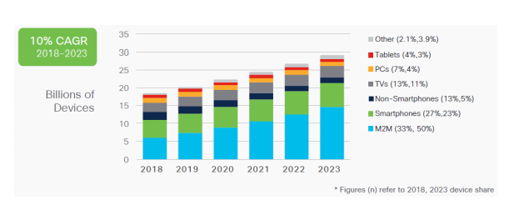

Figure 1.1: yearly development projections of development gadgets. Source: Cisco, 2015 [2].

The above figure clearly discuss about CAGR means compound annual growth rate and different gadgets in different years up to 2023.

**1.1.2 Massive-User MIMO (MU-MIMO) Communication System:**

In this MU- MIMO is started in base station (BS) which serves multiple users’ equipment’s in 80’s and it has not success commercial in 90’s. This concept was introduced by Marzetta in 2010 and he built upon initial stage of MU-MIMO technology and imagined as its huge scope and versatile type. After, it was investigated a wave of research and development activities in both business and the scholarly world.

In the massive MIMO the base station is used in large number of antennas with multi-users using the same time-frequency resource over the TDD channel. In this channel vector the UE terminals and Base station are assume a s orthogonal which can be perform of linear precoding algorithms it includes the ability of transmission of multiple data streams on downlink without inter channel interference and also vector orthogonal is known as favourable propagation in MU_MIMO research.

In antenna system logic behind the massive MIMO activity is moderately clear and it think about base station (BS) with M antennas. In RF chain the base station antenna (BSA) as a fixed part in transmitting. The signal power received with M antenna since a base station antenna (BSA) with the more components can also more productively centre the energy in the expected bearing.

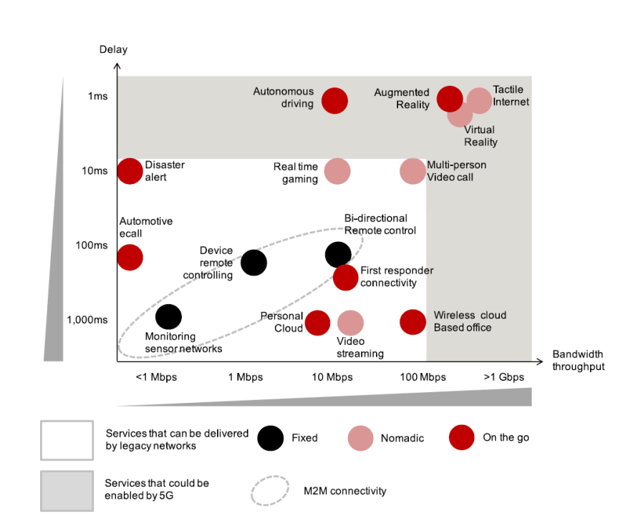

Figure 1.2: Throughput and latency equipment’s uses in 5G; source: GSMA Intelligence, 2016 [3].

The above figure clearly discuss­es about bandwidth and delay path in 5th Gen and Base station. In some of versatility of Massive MIMO infers in theory and infinite number of receiving antennas can also be used at base station to serve a greater number of clients. Furthermore, the system throughput is improving only in certain logarithmically with value M is increase. At last, the quantity of radio antennas is restricted to certain antennas are limited in physical dimension to below 6GHz spectrum.

The advantages of Massive MIMO are works multiple capacity of wireless connection without required high spectrum [12]. In better performance and possible signal path of data rate and link reliability is transmitter and receiver with antennas. In Massive MIMO has more responsible to device Tx in higher range and it will improve all coverages. The number of antennas of Massive MIMO have more resistant to interference in current system it only uses of antennas. It also be used for beamforming technology and enable to spectrum analyser.

* 1. **Massive MIMO with Antenna Communication system:**

In Massive MIMO application base station antenna (BSA) array are designed as a classical textbook antenna. It not only required for understating of electromagnetic theory but, also understanding global functioning of a Massive MIMO. However, the multi-user has Massive MIMO at initially array configuration might be high performs in spectral or energy efficiency (EE). In this certain design iteration might be need for optimal array configuration are be founded. Below figure clearly shows iterative co-design strategy involving with electromagnetic and some theoretical specification.

The mutual coupling in base station antenna array (BSA) are far as s-matrix STT ∈ CM x M and Embedded Elements Patterns (EEP) all things are needed to considered as a channel network, H∈CM x M. in this information can be obtained the estimation and the channel matrix requires S-lattice of the UEs. Expecting the single antenna user with no MC between the SRR are the inclining network ∈ C K x K.

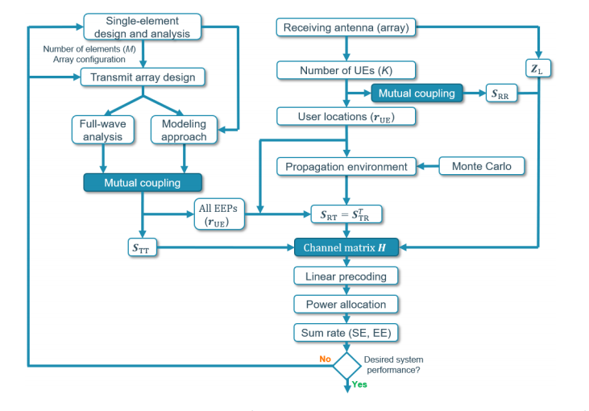

Figure 1.3: Electromagnetic and information theory based iterative co-design of BSA;

source: 5G guide, 2016 [3].

The above flow charts discussed about BSA, Mutual coupling of antennas and channel matrix.

* + 1. **Research of Antenna Array in MIMO:**

The Massive MIMO innovation was start with doubt and mostly determined by negative experience with MU-MIMO. In decade ago, innovation was experienced correspondence idea has proven by existence of two books [2]. After advances in Massive MIMO and Vision of future research has been given by Bjorn-son et al. [14]. This author started five research for antenna arrays. 1) Holographic Massive MIMO, 2) Large-scale MIMIO radar, 3) Extremely Large aperture array (ELAA), 4) six-dimensional positioning, 5) Intelligent Massive MIMO. Later on, they focus on three more application in that former two focus on high aspects of antenna array system.

In this antenna array Extremely Large Aperture Array (ELAA) has assume as a conformal array mounted on an available surface, for example., side of building, possibly with a generally huge receiving antenna separating in the wavelength. Furthermore, increasing array aperture has spatial goal of the Base Station antenna array (BSA) can be upgraded are subsequently expanding the chances of accomplishing idea spread conditions [5]. On the other hand, ELAA might be acknowledged using without cell free Massive MIMO idea by using this way single receiving antenna access point are dispersed around the clients and associated with a CPU.

A potential deficiency of using the ELAA has improved probability of imparting the close field of base station antenna array (BSA) because of its amazingly exhibit opening in this way we confuse the channel displaying [5]. The Holographic Massive MIMO of ELAA has standard of optical holography, imagines a correspondence idea dependent on a spatially constant opening, which is framed by stacking a huge number of receiving antennas into a fixed actual gap.

Finally, the implementation of massive MIMO was associate in to two pieces which are sub-6 and mm-wave regions and also hardware requirements and channel characteristics might be considered as a contrast. The challenging situation with implementation of Massive MIMO in this two-specific area of spectrum have been addressed [2].

* 1. **Sparse Array:**

The sparse array is an array of data which element is zero and this is contract to a dense array element have non-zero qualities or full of numbers. The sparse array as uniquely comparing dense array in digital data handling. For an example sparse array, sparse matrix may be compressed as a storage space in certain resource rather than holding the zero values in a variable, the array as zero value in sequence compress at arrays data storage. Although the effect of receiving antenna dividing in standard arrays for MU-MIMO interchanges has regularly been analysed. A 0.5λ spacing has widely become a norm for practical system realizations, where λ signifies the frequency.

In Massive MIMO notation is being challenged and the sparse array can be defined as array who’s the component separating surpasses in the regular 0.5λ spacing and it represent the possibility for the organization with regards to Massive MIMO system [2]. The sparse array was representing as a lattice or those that don’t display any detectable spatial designing.

So far, the sparse array was mainly focussed on satellite and radio astronomy applications. The uses of sparse array in Massive MIMO have been compared to conventional array with half wavelength spacing [5]. The mainly benefits of using sparse array is reducing the number of elements, Power variation and enhanced spatial resolution. The main drawback of sparse arrays is using lattice in the context of MIMO system which appeared in group of lobes. By using ISAs grating lobes can be suppressed as irregular array structure.

**Chapter 2**

**Mutual coupling in antenna Arrays**

In this chapter, a brief overview of Massive MIMO system and Mutual coupling in antenna array [2]. In this we discuss more about impact of MC and Analysis of MC, and numerical simulation of antenna array MC.

**2.1 Mutual Coupling in Phased array:**

The Mutual coupling between receiving antenna effects the parameter antenna like reflection coefficients, terminal impedances and the radio antenna exhibit execution regarding radiation attributes of output radar cross section (RCS) and Signal to interference noise ratio. In this mutual coupling effects is also known as direct or indirect influence towards transient response, interference rejection, resolution capability, and direction of arrival (DOA) these are competence of array. The phased array certain masterminded, limited size of antenna array components, are which taken by care of fitting feed organization. Furthermore, array which radiated from one antenna to receive another antenna and this way the signal might be get scattered, or reradiated, reflected.

The main properties of these elements are a signal depends on the reflection co-efficient, power of signal and additionally electrical phase is introduced due to delay of one element array to another element. By these type of interaction between antenna elements will lead to coupling effects and array characteristics. In other way, in an antenna array, the electromagnetic (EM) characteristics of certain antenna elements influenced to other elements and also themself by the elements in their proximity. In this mutual coupling between antennas is depends on various factors, relative orientation of elements, namely, interelement spacing, type and number of antenna elements (A), scan angle, direction of arrival (DOA), radiation characteristics of the radiator, bandwidth, and all the components of feed network are shown in the below figure 2.1.

The presence of mutual coupling in array antenna has changes the terminal impedances, array gain and reflection co-efficient. These are the fundamental properties of array antennas which influence on radiation characteristics, Radar Cross section (RCS) and Signal to interference plus noise ratio (SINR). Furthermore, it effects the transient response, resolution capability, steady state response, interference rejection ability, and DOA competence of the array.

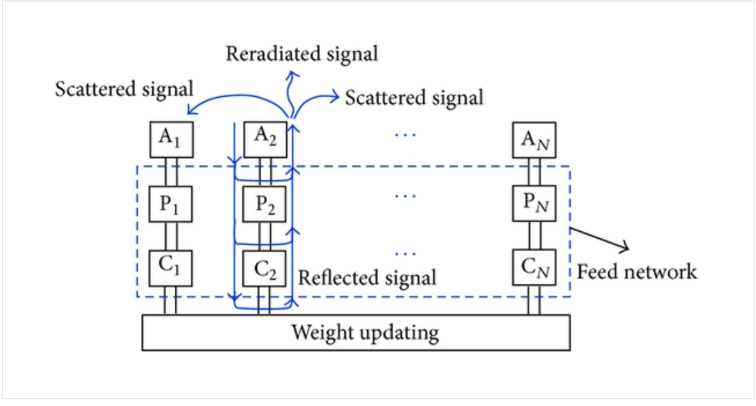

Figure: 2.1 Mutual coupling in phased array; Source: hindawi, 2004 [10]

The above figure clearly discusses about phased antenna array and also, feed network in phase shifters (P) and couplers (C).

The performance of array is obtained by using different techniques like Multiple signal classification (MUSIC), Scheme for spatial multiplexing of local elements (SMILE), Method of Moments (MOM), Estimation of Signal Parameters via Rotational Invariance Techniques (ESPRIT), AND Direct Data Domain (DDD) algorithms. The elements which can be used to mutual coupling are be extended towards the payoff of its effects. Furthermore, optimization techniques such as linear program (LP), particle swarm optimization (PSO), and genetic algorithm (GA) are can be used toward the array efficiency.

**2.2 Mutual Coupling and It’s Impacts:**

The impact of radio antenna array of mutual coupling is which modifies the impedance and radiation characteristics of receiving antenna array which plays important part as far as the component’s choice, array design and generally speaking, working of a massive MIMO [2]. For an example designing parameter of antenna arrays for Massive MIMO application, is the installed components acquire variety, brought about by mutual coupling and the edge impact because of a limited array element [7]. In finite array, each antenna elements sees similar surroundings. Therefore, the embedded components gain is equivalent to all the components. However, in a multipath channel, the installed components gain ought to in a perfect word to be omnidirectional to effectively get the signal components which shows up from different directions. In this huge varieties of the embedded elements gain acquire inside a receiving antenna array or excessively ordered embedded element acquire examples may debase the total rate execution of a Massive MIMO or present client as unfairness, it also depending on the choice of linear processing algorithms [2,7]. In a limited array location of an antenna within an array decides its embedded components are acquired. Hence, depending on element and array has significant embedded gain the variation in between the element will be appear.

For example, consider two components normally utilized in experiments involving and theoretical analyses are the Massive MIMO patch antennas and dipoles. Firstly, a dipole receiving antenna produce an omnidirectional radiation design in the H-plane system, while fixing an antenna is more directive. By assuming that isolated element will be only translate to array environmental, while fixing dipole array would be exhibits a smaller embedded gain compared to array patch of antennas. Furthermore, dipole antenna should first appear to be more appropriate applicant component for the sending in antenna arrays for Massive MIMO system [7,8]. In any case, dipoles inserted in an array climate show stronger mutual interaction compared to patches, which may also impact the installed components on the embedded element gain more variation and the omni-directionality of the isolated components. Subsequently, may be counterintuitively, patch array is better choice from this point of view.

In a similar paper, the impact of the embedded gain variation from the client rate has been broke down and it showing the affectability of a Massive MIMO system to the point of appearance concerning in the client location [7,8]. Another significant boundary of a receiving antenna array related to mutual coupling is the embedded radiation effectiveness and also it accepting lossless antennas. In embedded elements the fraction of the on each port is coupled to all other ports. Additionally, the ability of antenna radiate is accepted into the space is degraded with increasing mutual coupling to other ports. In this embedded element effectiveness addresses a principal impediment for MIMO system, especially with regards to imagined large antenna arrays for MIMO system. Also, the Active reflection co-efficient is a significant plan for variable as it describes the induced antenna due to mutual coupling from another effectively determined phased array antennas.

In this performance of Massive MIMO is benefit from optimal element selection in the lower term of inter element coupling system. In a mutual coupling (MC) of MIMO system has overview of the de-coupling techniques used in massive MIMO system and its impact of mutual coupling performance, this system form in four steps, namely the diversity gain, error rate, channel capacity and spectral regrowth [7, 10]. Furthermore, the diversity is a concept of communication system which can used for more than single antenna on the receiving channel, and also each antenna is a part of receiver channel and it receives a copy of the transmitted signal. In this receiving antenna may misuses spatial diversity, its being separated by some distance are getting on alternative polarization system. In this way joining the receiving signals in an appropriate manner then the probability of fading can be easily reduced. Also, combining the signal to noise ratio (SNR) should be ideally considered as a diversity of antenna. The relative value of SNR in a single diversity antenna is also called as diversity gain. In this diversity gain of Mutual Coupling as a channel capacity and error rate performance these depends on correlation and efficiency. Finally, the system impact of mutual coupling has not straightforward [6,10].

Therefore, the conclusion, Mutual coupling in Massive MIMO has appears spatial diversity, general array configuration, optical system performance, SNR, and spacing antennas.

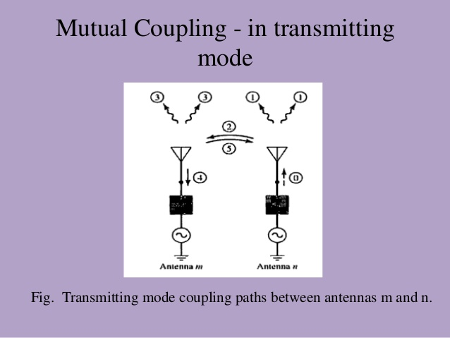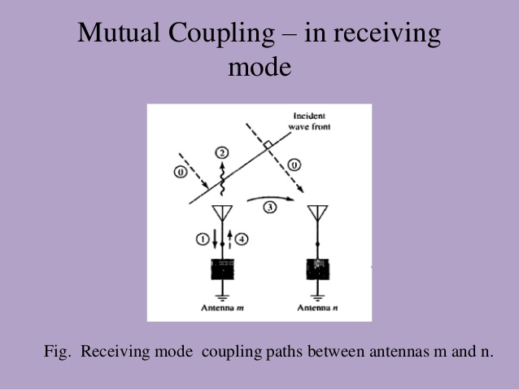

Figure: 2.2 Transmitting and Receiving Mutual coupling antenna; Source: TTI antennas, 2011 [15]

The above images clearly show the transmitting and receiving mode in between mutual coupling of antennas arrays with M an N symbols.

In mutual coupling we can also use S-parameters, coupling matrix, Mutual Impedance and embedded elements pattern [10].

**2.3 Analysis of Antenna array with Mutual coupling:**

The analysis of mutual coupling antenna arrays is given, the relation between the embedded elements, array impedance matrix and beam coupling factor are the general types of antennas [10]. For a normal exhibit, a typical Fourier-based formalism is used in antenna array, it also be a key tool in array scanning method. By explaining relationship between the finite and infinite arrays are at physical and numerical level. The major important characteristics of an antenna array are radiation pattern and input impedance, these two are completely depends on quantities. While thinking about a array with only one element energized of neighbouring components may also be viewed as an augmentation of the energized antenna. The impedance of the resulting antenna is also called as active and passive impedance, and its radiation design is also known as embedded element pattern.

The basic estimation to finite array effects on embedded array is introduced by Stutzman and Kelley at 1993, whether the differentiation is made between core and edge elements in the antenna array. A N-element array can also be viewed as a N-port device with its own scattering matrix, and also N-port scattering matrix are called as mutual coupling co-efficient. However, it is essential to remember that, with the exception of unique cases, the information on the coupling co-efficient doesn’t give a complete image of the impacts of “mutual coupling” [10,11]. In generally, the radiation pattern of the isolated element and the N-port scattering matrix isn’t adequate to acquire the all-embedded element pattern. By this way we made more clear and also, we treat as a limited case of the single mode antenna elements.

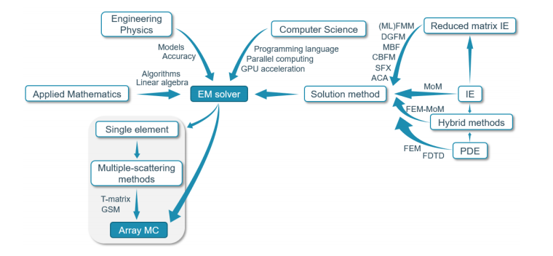

Figure: 2.3 Analysis of antenna array mutual coupling with the numerical simulation software;

source: Wikipedia

The above figure clearly discusses about antenna array mutual coupling with individual methods [10].

In this impedance matrix of a dipole array got in this manner can be utilized for describe mutual coupling in the Base Station Antennas [5]. By the non-line-of-sight (NLOS) propagation climate including dipole scattering we can easily calculate the channel matrix and also its should be applied as self-interference cancellation scheme in a full duplex MIMO system. In Mutual Coupling should be assessed mathematically by utilizing with EM solver which clearly mentioned 2.3 Fig. the EM solver is a perplexing instrument which organizes the ideas from various orders, for example, applied computer science, engineering physics and mathematics to be obtain the accurate answer for certain mutual coupling in a reasonable time period [11]. Furthermore, the two previous computational backbone of the solver, material and port definition, meshing, boundary conditions, parameters, these are client controlled and impact of arrangement in time and accuracy.

As to arrangement strategy, the two principal arrangement methodologies can be recognized as a mathematical description of maxwell’s equation in the integral equation (IE) structure or other partial differential equation (PDF) structure. The previous incorporates the methods of moments (MOM) are which includes the finite element method (FEM) or finite differential time domain (FDTD) strategy. On the other hand, the hybrid approach can be utilized in which antenna element is partitioned in various regions and also each region is solved by using most fitting arrangement technique for that regions. In these type ideas are also known as full wave Computational Electromagnetic (CEM) methods and it may suffer with poor computation and memory scaling when the electrically large antenna issues should be analysed.

|  |  |  |
| --- | --- | --- |
| **Method** | **Run time** | **Memory** |
| MoM | N3X | N2X |
| MLFMM | NX log2 NX | NX log NX |
| DGFM | N x N3i | N2i |
| CBFM | N6 | 2N2i + N4 |
| ACA | NX4/3log NX | NX4/3log NX |

Table 2.3.1: Computational complexities of several IE based methods [13].

Here, N is the number of elements, Ni is the number of unknowns per element while NX =N x Ni is the total number of unknowns objects.

The main concept aim is to reducing the computational complexity. In this mostly include the domain green’s function method (DGFM), synthetic function approach (SFX), adaptive cross approximation algorithm (ACA), characteristic basis function method (CBFM), macro basis function approach (MBF). In these computational complexities of several IE-based techniques are compared in 2.3 Table. In this domain decomposition method (DDMs) are represents as a latter approach. It also used for reducing the number of unknown problems in array geometry.

Based on modelling principle for mutual coupling as a different multiple scattering system can be recognized [11]. Example., T- matrix strategy relates in a spherical wave expansion (SWE) of an approaching wave can be scattered and also this SWE is active (outgoing) wave. Furthermore, the generalized scattering matrix (GSM) approach the model have both the field impacts of utilizing to the SWE and the reflection at antenna ports, reflecting the physical nature of mutual coupling because of the outer excitation [10,11].in this expansion wave concept (EWC) and the interaction between the components are demonstrated by utilizing the logical Green’s function estimate for separated dielectric media. In addition, the standards of various scattering might be utilized to process the characteristic modes within the sight of mutual coupling and this may be giving a valuable physical insight into the characteristic’s mode inspired antenna design for Massive MIMO applications [7].

**Chapter 3**

**IEEE 802.11 Wireless LAN system**

IEEE 802.11 is a part 802, it is popularly known as WIFI 802.11. it defines in specification for a wireless LAN which covers physical and data link layers [12]. There are two types of services are used in 802.11 is Basic service set (BSS) and Extended service set (ESS). Firstly, BSS has made up of stationary or mobile wireless station and Access point (AP) [1]. In any BSS without AP, it is a stand-alone network and it cannot send data to any other BSS. This kind of network is also known as Ad-hoc architecture. In infrastructure network which can communicate with AP to other BSS. Secondly, in this ESS data transfers from one station to Access point with the help of distribution system data moves other station. The WLAN is also using for high frequency radio waves for connecting the different nodes [9,15].

**3.1 IEEE 802.11 Wireless LAN and its Standards:**

The IEEE 802.11 WLAN has relevant standard which is 802.11, 802.11a, 802.22b 802.11g, 802.11n and 802.22p. these all standards are used with carrier-sense multiple access with collision avoidances (CSMA/CA). this also support for bot BS and Ad-hoc networks [15].

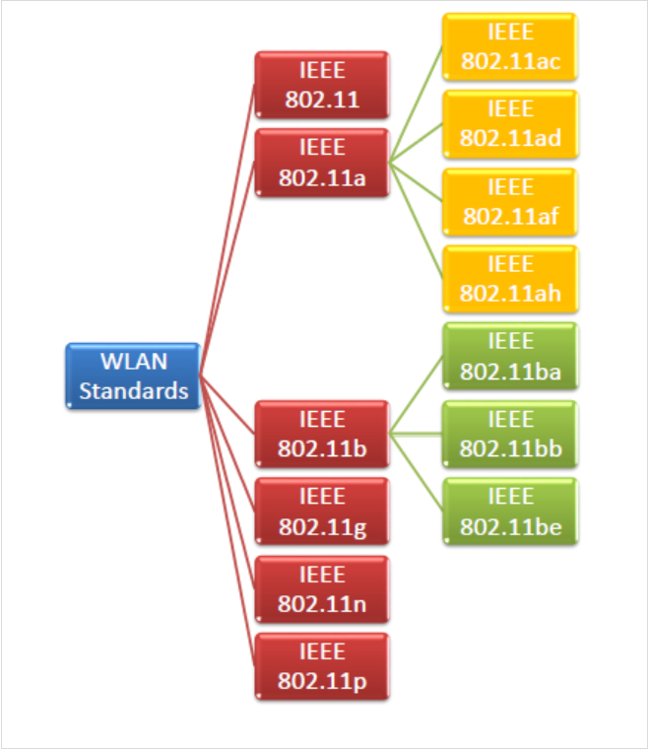

Figure: 3.1: IEEE 802.11 Wireless LAN and its Standards; Source: tutorials points

The above figure clearly discussed about standards of IEEE 802.11 WLAN and its types.

In this Wireless Local Area Network (WLAN) beginning in 19th century for 900 MHz, 2.4 GHz & 5 GHz. In June 1997 (IEEE) Institute of Electrical and Electronics Engineers as defined standard is 802.11 [15]. In this Standard Specifies a number of (MAC) Medium Access Control and 3 other physical layers (PHYs) these are based on radio communication by using 2.4GHz. WLAN is a wireless computer Network that which connects two or more devices by using different wireless communication Network to be a LAN and this range is limited area such as an office building, university campus, laboratory [9,12].

**3.2 IEEE 802.11 Wireless LAN protocols:**

In this WLAN is stands for wireless Local Area Network this is use for high frequency radio waves rather than links for associate the devices. It can also imagine bunch of PCs and other wireless devices communicating with the radio signals [15]. The WLAN can only move inside of the network coverage area.

**3.2.1 Wireless LANs and its configurations:**

In WLAN each station has a wireless network interface controller. These stations can be divided into two types-

* **Wireless Access point (WAP):** WAPs are generally wireless routers it forms the base station, WLAN is used for large buildings, offices, commercial places. In this Access point are connects to wired routers, hub, ethernet cable and switch these are all distribution system. A WAP act as a stand-alone device and it can also be used for extending the wireless coverage of the existing network. A WAP is also called as hotspot [12].
* It generally called as IEEE 802.11 AP with maximum clients 10-25. In this Access point ad-hoc network is used for quick data exchange.
* The Wireless access point and wireless routers are both support for Wi-Fi network connections and performance.

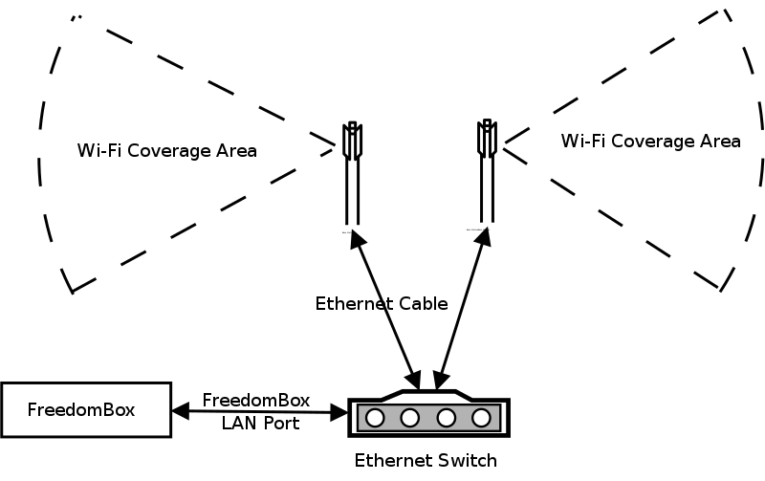

Figure: 3.2.1(1): wireless access point (WAP); Source: tutorials point

* **Client:** The Access point connects from wired to wireless device with help of client mode. This mainly suitable for wired devices with an ethernet ports and wireless devices, computer, laptops, TV, Media player, printers, smart phones etc [12]**.** The wireless client can only communicate with Access point mode and this mode allows the access point to become a one client to other access point. 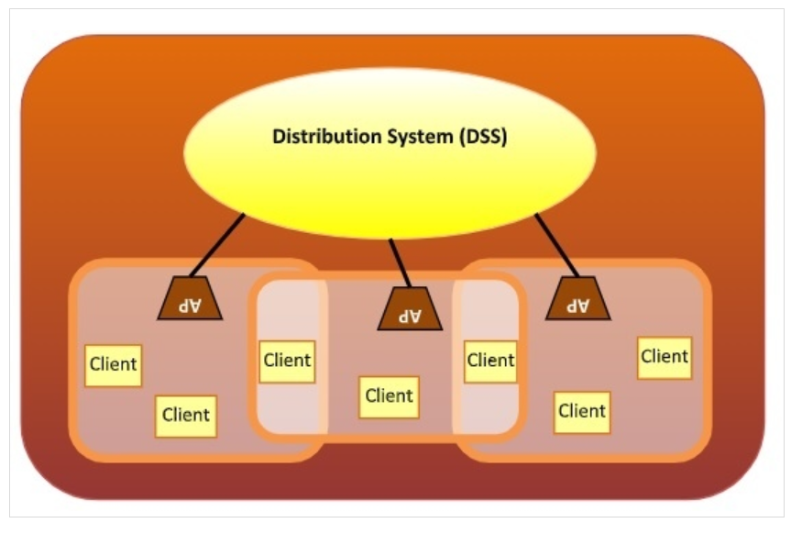

Figure: 3.2.1(2): DSS and client; source: tutorials point

**Types of WLAN protocols:**

* **802.11a protocol**: This protocol mainly supports very high transmission speed 54Mbps and high frequency rage is 5GHz. It employs the Orthogonal Frequency Division Multiplexing (OFDM), which can suitable for certain office environment and also digital data can easily transmit wireless from different frequencies [14].
* **802.11b protocol:** This protocol operates within the 2.4GHz frequency range and it supports 11Mbps bandwidth speed. In this data sharing is less speed comparing to 802.11a. it employs the Carrier Sense Multiple Access with Collision Avoidance (CSMA/CA) with Ethernet protocol. In this data implementation is low cost with a better data transmission signal comparing other protocols.
* **802.11g protocol:** This is newly protocol in 802.11 family in 2002-2003. It is a combination of 802.11a and 802.11b protocols. It supports both range frequency which 2.4GHZ and 5GHZ. This provides high speed with large signal range of data and implementation is more expensive comparing other protocol.
* **802.11n protocol:** This protocol is popularly known as Wireless N, and it is an upgraded version of 802.11g. it provides very high bandwidth up to 6000Mbps and it uses of Multiple input/ multiple output (MIMO) technology. By this way creates multiple antennas at both transmission and receiver signal. It is a high resistance to external interference and better signal coverage with large radio channel frequency. In this implementation is highly expensive comparing other protocols. This protocol is 10 times faster than 802.11g protocol.

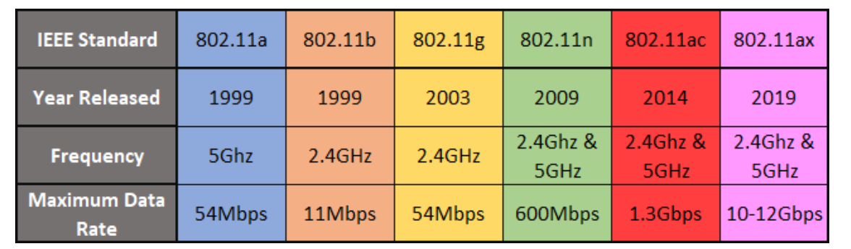

Figure: 3.2.1(3): WLAN / Wi-Fi standards; Source: MUO-Technology, 2018 [9]

**3.3 Channel sounding For MIMO system**

**3.3.1 Channel sounding data of Tx and Rx signal:**

The channel sounding is a procedure that evaluate the radio climate for WLAN system [14]. It is also combination of both of software and hardware system in channel sounding [21]. In this 5G mm Wave frequency has high performance to supports ultra-wide bandwidth in MIMO. it has fastest data capture nature with processing of wideband MIMO system and real-time correlation. The channel sounding measures with system-wide calibration, synchronization, and precise timing [21]. it also has flexible and scalable to develop the 5G in MIMO channel [3]. The channel sounding performs as Tx/Rx up to 44GHz with 1GHz bandwidth in 4, 6, or 8 MIMO channel [4,15].

In channel sounding FPGAs has some performance which is capture multiple phase coherent for real time processing channel impulse response (CIR). It also has I/O control synchronizes which is Tx and Rx to < 1 e-12 accuracy and < 1 e-12 stability in channel sounding MIMO system [21]. It includes I/O control system which allows the synchronization between the Tx and Rx, and also channel-to-channel performs to achieve the accurate measurements is also delay at AOA and AOD. The software which creates waveform in channel sounding is with the help of I/Q imbalance, Phase skew, Multichannel magnitude, and power. To measure performance of Real time CIR is with M9703A Axle digitizer FPGA is required disk space and reduce of data collection. By using System Vue software we can estimate channel parameter, path delay, Doppler shift, and AOA. Finally, once the system Vue software can understood we can easily use to link-level simulation for new 5G technology designs [3].

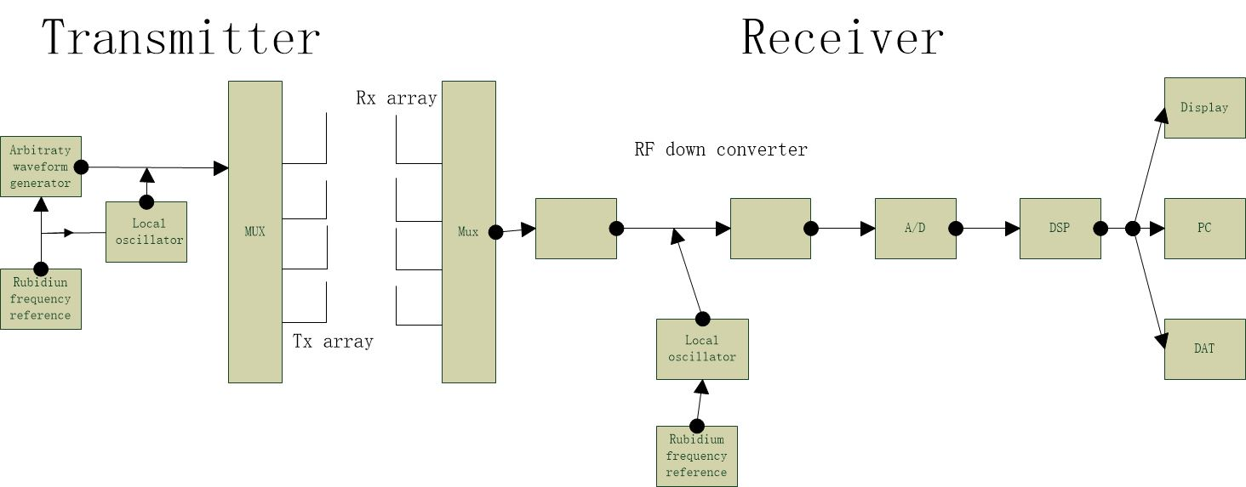

Figure: 3.3.1 channel sounding data of transmitter (Tx) and receiver (Rx) signal: Source: Wikipedia

**3.3.2 Precoding in MIMO system:**

The precoding is mainly used for multi-layer transmission antennas in wireless communication system [15,22]. In this we use single stream beamforming with same signal to transmit the antennas and signal power should be get maximum output at receiver. To analyse the maximum throughput, we required multiple receiver antenna and multiple stream transmission system. In a briefly, precoding means multiple data streams in a transmitting antenna with independent and link throughput to get maximum output of receiver channel [16]. In some of MU-MIMO data has streams in different users and measures maximum throughput [15, 18]. In precoding have some benefits is without requiring channel state information at the transmitter and it is also essential for handling the inter user interference in MU-MIMO system [18].

The precoding down-link of cellular network is also called as MIMO network, or Co-ordinated Multipoint (COMP) is to observe the MU-MIMO system [18]. In precoding the transmitter (Tx) coded data to receiver to achieve the pre- knowledge of the channel [22]. The precoding receiver does not have channel state information and it is a simple detector. This strategy will be decreasing the corrupted impact on the correspondence channel. For an example, take ‘s’ is sending information, channel ‘h’ is pass through the channel ‘s’ and add Gaussian noise is ‘n’. finally front end of receiver will be r= sh + n. in this receiver channel we have to know about ‘h’ and ‘n’ information. Channel ‘n’ will be increase SNR and channel ‘h’ will be increase complexity. In this precoding (MU) mobile unit must be simple because of size or cost and base station (BS) has hard work and predict the channel capacity. Let us consider, the predicted channel is hest and precoder information is s/hest. The final received signal should be r = (h/ hest) s + n. In this assume hest = h and r = s is should be a problem for Gaussian channels.

The precoding doesn’t counteract the effect of the channel and it adjust the transmit vector with the eigenvector of the channel. Briefly, the transmit symbols vector which transforms towards receiver in the strongest form [22]. In precoding point to point MIMO system has transmitter and receiver which communicate with multiple antennas [14,15]. In classic precoding we can assume that slowly fading channel, narrowband channel and these channels can be described as single channel matrix with slow changing process. In this precoding methodology that maximizes the throughput is known as channel capacity. In statistical channel, receiver known as channel matrix and transmitter knowns as eigen beamforming these to achieve the MIMO capacity channel. In channel covariance matrix the transmitter will be emits in multiple streams with eigendirections [16,18].

In MIMO channel capacity the channel matrix is also as singular value decomposition (SVD) precoding. By this channel matrix is will be de-classed by SVD and also remove the two unitary matrices at transmitter and receiver through the pre and post multiplication. In SVD one data stream per singular value can be transmitted by creating without any certain interferences. In MU-MIMO has multiple transmitter antennas which communicates with multi- receivers and this is also called as space division multiplexing access (SDMA) [15,18]. In SDMA algorithms are divided into two type is linear and non-linear precoding. The linear precoding usually achieve better performance with lower complexity and non-linear precoding are achieved capacity algorithm. The linear precoding designed strategy is Maximum Ratio transmission (MRT), Transmit Wiener precoding and Zero forcing (ZF) and this precoding has low-rate feedback like a random beamforming [22]. The non-linear precoding is designed as Dirty Paper Coding (DPC), it is also known interference at transmitter which deduct without taking any penalties of radio signal. The MU-MIMO cannot perform to all users and it is viewed as a Multi Object Optimization problem which each capacity as one user [18].

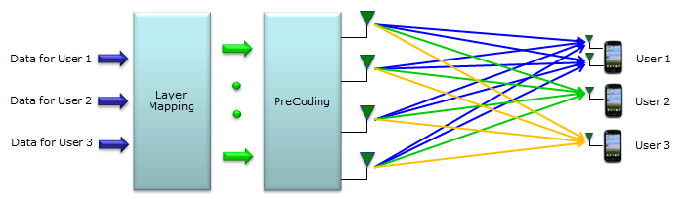

Figure: 3.3.2: Precoding for Multiple users in MIMO system; Source:5G MU-MIMO, 2016[22].

The above figure 3.3.2 is clearly discussed about multiple transmit users with layer mapping and precoding to multiple received users.

**3.3.3 Shadowing Effects in MIMO System:**

The Shadowing effects are ­­­­­characterized as the impact of received signal for power fluctuation because of obstacle between the transmitter (Tx) and receiver (Rx) signal. In this way, the signal results changes from scattering and reflection during the transmitter shadowing [19]. In this shadowing effects results will be bending lights and this transmission doesn’t follow the straight line. As part of large-scale fading is more impact on small scale fading in shadowing [19]. Below we clearly explain equation of denoting the ratio of transmitting and receiver power as γ = γ Pt/Pr….,

P(γ) = ζ / √2Пσγdbγ exp [ - (10 lg γ-μγdb)2 /2σ2γdb],

Where ζ = 10/ ln10, σγdb this means γdb = 10lgγ, these are mostly σγdb standard deviation γdb.

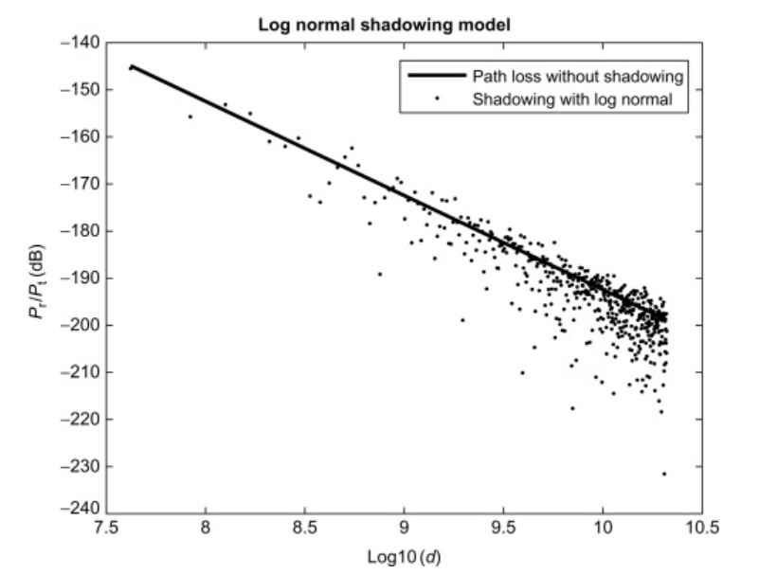

Figure: 3.3 (1): shadowing model with log normal; Source: Science direct

The above figure show effects of shadowing to wireless propagation, analysis and path loss light with LOS.

The shadowing has more impact on bit error rate and capacity performance of MIMO system [19,20]. Normally, shadowing is distributed in different pathloss systems and obtained by moving the receiver over relatively large distances [19]. This model originally proposed to cellular and car mounted receiver system. It has standard model in cellular system is 3GPP model, COST 259 model, COST 273 model. The shadowing has many insufficient in PAN, due to lateral movement and rotational of the user in antennas. This is identified as between the shadowing caused surrounding objects and the body [20]. In this shadowing has various types of fading statistics and coherence times. We compare two types of shadowing effects is 2.6GHz and 5.2GHz.

The combination of small-scale fading and large-scale fading is known as shadowing [19]. In this component impinging has constructive and destructive interference in a receiver signal. It is also typical to assume the large-scale variation in the physical environmental of the receiver signal and it occurs mobile station (MS) moves over the large area. Normally, it has described has normal process function with amplitude probability density function at log-normal and auto-correlation system. In shadowing the correlation length is 10- 100m and fluctuation as two points separated one by one correlation length will roughly de-correlated [19].

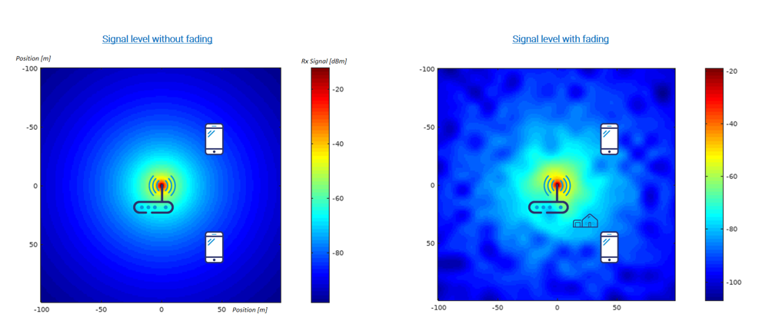

Figure: 3.3 (2): Shadowing signal level with and without fading channel; Source: Grand metric

**Chapter 4: Results**

The 802.11ac Multiuser MIMO precoding is to support the downlink of multiple transmission up to 8 transmitter antennas. This multiple transmitter users with same interval and reduce the all taken time for multi-transmission. The transmitter comes to high complexity with individual users in precoding is also known as transmit-end beamforming. This precoding is assuming channel state information (CSI) at only user transmitter. Each user feedback has individual CSI to beamforming and these users are set to precoding matrix for subsequent data transmission.

In this simulation used with some of parameters and configuration, channel sounding, channel state feedback, data transmission, data recovery per user.

**Channel sounding:** It is a first channel to determinechannel receiver (Rx) and this information is sent return to the transmitter (Tx) for the use of data transmission. In this we assume that channel has 2 transmission for multi users to transmit the data in scheduled to receiver.

**Transmission Channel:** In Transmission channel has multi user channel consist of independent single user channels in between the spatial station and access point. The flat fading channel is allowed in a simple receiver without any front-end synchronization and it is also number of users receiving antenna is equal to space time streams. To store per user elements which is allow a flexible number of users by the help of cell array.

**Channel state information Feedback:** In this each receiving channel signal information should be sent return to channel transmission signal. Below simulation shows clearly about singular value decomposition of the channel in each user to compute channel state information (CSI) feedback.

**Data transmission:** The Data transmission are random bits which used as a payload for the individual users and to hold the data bit is used with cell array (txDataBits). In this multi user transmission has individual user payload are padded to the Tx it is same for all channel users. To create the PSDU user the payload is padded with zeros.

**Data Recovery Per User:** In this receiving signal for each user are processed in individual and there are no front-end impairments, transmit configuration is called as simplicity of receiver.

For transmission the user number is specifies the user of interest to be decoded. It is also used for vector properties in a specific user.

In this 6x6, 8x8 configuration with three users, where three, one, four of number of users are changed in 6x6 one, two, three and 8x8 changed as one four three and also, we change the (BER) bit error rate, the small number of BER with noise is indicate to data decoding is successful for all the users and different EVMs.

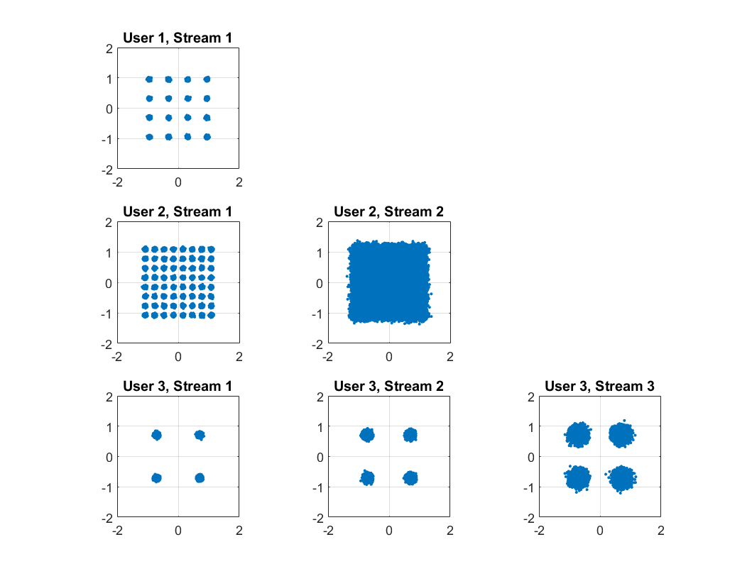

Figure: 4.1: 802,11 ac Multiuser MIMO precoding in 6x6 matrix.

The above figure clearly discussed number of users, streams, antennas in 6x6 matrix

In this precoding, channel sounding used for same number of streams and indoor office is used for access point to set up layouts in parameters. It also assumes that number of receiving antennas is equal to space time streams.

The channel filtering delay is also known ‘numPadZeros’ is used for store the user antennas of transmitter and receiver. Data transmission is used for payload of the individual users and hold the data bits. Data recovery per users is used for receiver signal to process the individual users. This user can be decoded for transmission and also used for vector properties on user specifications.

Furthermore, the multi user transmit configuration, individual transmitter, receiver processing and independent per-user channel are these used for channel inversion precoding techniques,



Figure: 4.2: 802,11 ac Multiuser MIMO precoding in 8x8 matrix.

The above figure clearly discussed about number of streams, antennas, users.

Finally, winner II fading channel of 802.11ac has exploration of transmission parameter, antenna array, channel scenarios. LOS, shadowing, path loss modelling, NLOS propagation.

 

Figure: 4.3: Bit Error Rate Analysis.

The above figure shows Bit Error Rate (BER) analysis of convolutional coding. In this BER discussed the compute SERs and BERs by using different simulation and it helps gather empirical error statistics. Generally, bit error rate is a digital transmission which number of bits per unit time and it performs unitless to measure percentage. In results used minimum free distance and distance spectrum which mentioned Eb/No(dB), Energy per bit to noise power spectral density ratio.

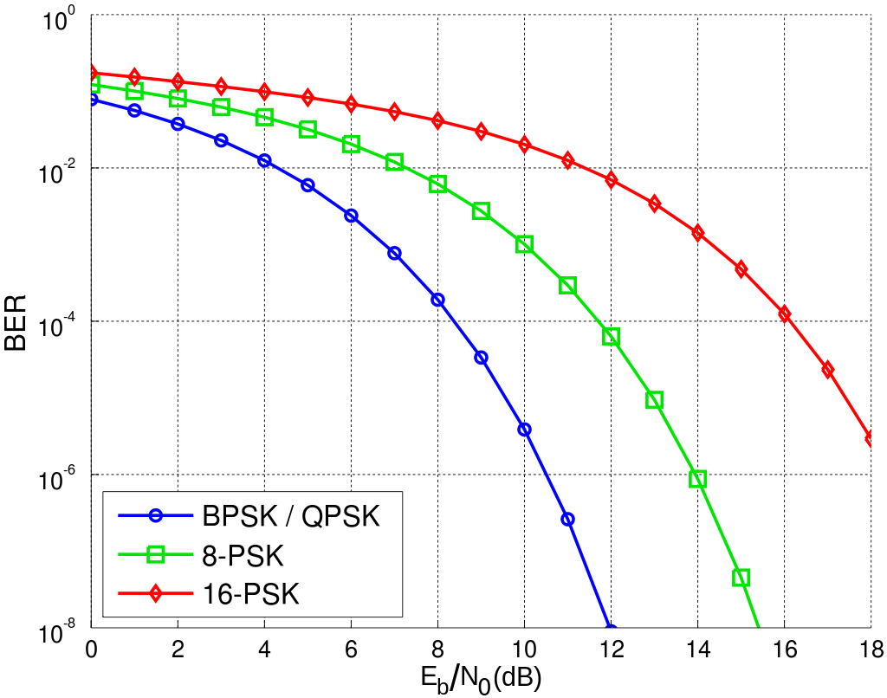

Figure: 4.4: BER with different techniques. Sources: Wikipedia

There are different types of digital transmission techniques:

* **ASK:** Amplitude shift keying it can be represented in digital data to amplitude of a carrier wave.
* **FSK:** Frequency shift keying it can be represented in digital data is transmitted with discrete frequency changes of a carrier wave.
* **PSK:** Phase shift keying it can be represented in digital data is transmitted phase of a constant frequency carrier wave.
* **BPSK:** Binary Phase shift keying it can use with two phases separated by 1800.
* **QPSK:** Quadrature Phase Shift keying it has four PSK or QAM.

**Conclusion**

This thesis has presented a wealth of comprehensive research on MIMO system for Wireless LAN application, we discussed step by step process in chapter 1 we discussed as MIMO system, standards, Sparse array, MIMO types. In chapter 2 we discussed about Mutual Coupling in antennas, array types and MC of Tx and Rx. In chapter 3 we discussed IEEE Wireless LAN, Channel sounding, precoding of MIMO system and channel shadowing in MIMO. To more deeply understanding of MIMO is obtained has a unified framework, physical interpretation and theoretical performance. In this we mention in chapter 1 about MIMO system has simplest SDN techniques is also called Zero Forcing (ZF) at receiver antenna array. In MIMO free space Line of Sight (LOS) has unwanted null direction to wanted null direction with “interference”. In this chapter we also discussed about Massive MIMO is a new technology and it provide a good service to wireless communication. In one-word Massive MIMO is refers as Number of antennas in not a physical size.

Chapter 2 we discussed about Mutual coupling in antenna arrays is effect on the Tx and Rx in parameter antenna and it attributes output of Radar Cross Section (RCS), signal-to-interference noise ratio. This also effects direct and indirect influence towards the transient response, interference rejection, DOA and resolution capability. The delay of one element to other element is also known as Mutual coupling in antenna array. In other words, in MC electromagnetic influenced to other element and mean time themself by the help of element proximity.

Chapter 3 we explored as Wireless LAN in IEEE 802.11, the WLAN which covers the physical and datalink layer. In 802.11 has two services they are base service set (BSS) and extended service set (ESS). In BSS has made up of wireless station and AP, the BSS have two nature one is BSS without Access point and anther BSS with Access point. We also discussed IEEE 802.11 WLAN standards, protocols, channel sounding, precoding, shadowing in MIMO system.

In chapter 4 we discussed 802.11ac Multi-users in MIMO precoding this chapter completely done in MATLAB application. It is mainly focussed on support of downlink multi transmission in different configuration like 4x4, 6x6, 8x8 and 16x16. We also clearly mention in different results of users, steams, data recovery, data storage, precoding, WLAN toolbox, channel sounding, channel bandwidth, bit error rate (BER).

**References**

[1] R. Ling, “Mobile communication,” in International Encyclopedia of the Social and Behavioral Sciences, 2nd ed., J. D. Wright, Ed. Amsterdam and Oxford, UK: Elsevier, 2015, pp. 629 – 635.

[2] T. L. Marzetta, “Massive MIMO: An introduction,” Bell Labs Technical J., vol. 20, pp. 11–22, Mar. 2015.

[3] European Commission. (2016, Sep.) 5G for Europe: An action plan.

[4] L. Sanguinetti, E. Björnson, and J. Hoydis, “Toward Massive MIMO 2.0: Understanding spatial correlation, interference suppression, and pilot contamination,” IEEE Trans. Commun., vol. 68, no. 1, pp. 232–257, Jan. 2020.

[5] N. Amani, “Sparse array architectures for 5G base station antenna design,” Licentiate thesis, Chalmers University of Technology, Göteborg, May 2019.

[6] T. L. Marzetta, E. G. Larsson, H. Yang, and H. Q. Ngo, Fundamentals of Massive MIMO. Cambridge, UK: Cambridge University Press, 2016.

[7] E. Björnson, J. Hoydis, and L. Sanguinetti, “Massive MIMO networks: Spectral, energy, and hardware efficiency,” Foundations and Trends® in Signal Process., vol. 11, no. 3-4, pp. 154–655, Nov. 2017.

[8] H. Q. Ngo, E. G. Larsson, and T. L. Marzetta, “Aspects of favorable propagation in Massive MIMO,” in 2014 22nd European Signal Process. Conf. (EUSIPCO), Lisbon, Portugal, Sep. 2014, pp. 76–80.

[9] S. Wang, Z. Chen, Y. Xu, X. Wang and Q. Kong, "Practical User Selection with Heterogeneous Bandwidth and Antennas for MU-MIMO WLANs", IEEE Wireless Communications Letters, vol. 8, no. 2, pp. 556-559, 2018.

[10] J. W. Wallace and M. A. Jensen, "Mutual coupling in MIMO wireless systems: A rigorous network theory analysis", IEEE Trans. Wireless Commun., vol. 3, no. 4, pp. 1317-1325, 2004.

[11] R. R. Ramirez and F. De Flaviis, "A mutual coupling study of linear polarized microstrip antennas for use in BLAST wireless communications architecture", Proc. IEEE Symp. Antennas Propag., pp. 490-493, 2000.

[12] J. Li and E. Y. Zhang, "A stochastic MIMO channel model and the analysis of the spatial correlation properties", Proc. Int. Conf. on Wireless Communications Networking and Mobile Computing, vol. 1, pp. 131-134, 2005-Sep.

[13] [Fractal monopole antenna for WLAN USB dongle](https://scholar.google.co.uk/scholar?oi=bibs&cluster=6996951675553955807&btnI=1&hl=en) Q Luo, JR Pereira, HM Salgado - 2009 Loughborough Antennas & Propagation 2009.

[14] [EBG PIFA design for WLAN applications](https://scholar.google.co.uk/scholar?oi=bibs&cluster=5066686182698586600&btnI=1&hl=en) Q Luo, HM Salgado, JR Pereira - 2008 IEEE Antennas and Propagation Society 2008.

[15] [Compact printed monopole antenna with chip inductor for WLAN](https://scholar.google.co.uk/scholar?oi=bibs&cluster=14237857417884355127&btnI=1&hl=en) Q Luo, JR Pereira, HM Salgado - IEEE Antennas and Wireless Propagation Letters, 2011.

[16] [Alternating rate profile optimization in single stream MIMO interference channels](https://scholar.google.co.uk/scholar?oi=bibs&cluster=5953262098018438314&btnI=1&hl=en) R Mochaourab, P Cao, E Jorswieck - IEEE Signal Processing Letters, 2014.

[17] E. Masson, Y. Cocheril, M. Berbineau, J. Ghys, J. Kyrolainen and V. Hovinen, "4×4 MIMO channel sounding in tunnels for train-to-wayside communications," 2012 International Conference on Wireless Communications in Underground and Confined Areas, 2012, pp. 1-5.

[18] H. Tran, T. Mai, S. Dang and H. Ngo, "Large-scale MU-MIMO uplink channel estimation using sounding reference signal," 2018 2nd International Conference on Recent Advances in Signal Processing, Telecommunications & Computing (SigTelCom), 2018, pp. 107-110.

[19] K. Saito, K. Kitao, T. Imai, Y. Okano and S. Miura, "Data analysis and modeling method for indoor human body-shadowing MIMO channels," 2012 6th European Conference on Antennas and Propagation (EUCAP), 2012, pp. 1431-1435.

[20] N. Noori, "Shadow fading modeling across antenna elements of massive MIMO arrays," 2016 16th Mediterranean Microwave Symposium (MMS), 2016, pp. 1-4.

[21] G. Sommerkorn, M. Käske, C. Schneider, S. Häfner and R. Thomä, "Full 3D MIMO channel sounding and characterization in an urban macro cell," 2014 XXXIth URSI General Assembly and Scientific Symposium (URSI GASS), 2014, pp. 1-4.

[22] C. Chen, Z. Yang, C. Chen and Y. Huang, "A generalized eigenvalue decomposition processor for multi-user MIMO precoding," 2016 IEEE Asia Pacific Conference on Circuits and Systems (APCCAS), 2016, pp. 281-284

**Bibliography**

* **Help from internet:**
* [https://www.meraki.cisco.com/blog/2011/02/mimo-why-multiple-antennas-matter](https://www.meraki.cisco.com/blog/2011/02/mimo-why-multiple-antennas-matterl)
* <https://www.linksys.com/us/r/resource-center/what-is-mu-mimo>
* <https://www.mdpi.com/1424-8220/20/10/2753/htm>
* <https://www.gov.uk/government/publications/5g-mobile-technology-a-guide>
* <https://www.hindawi.com/journals/ijap/si/525828/>
* <https://en.wikipedia.org/wiki/MIMO>
* <https://www.hindawi.com/journals/ijap/2013/348123/>
* <https://www.tutorialspoint.com/multiple-input-multiple-output-mimo>
* <https://www.tutorialspoint.com/what-are-ieee-802-11-networks>
* <https://www.sciencedirect.com/topics/computer-science/massive-mimo>
* <https://www.grandmetric.com/2018/02/07/what-is-mimo/>

**Appendices**

%% 802.11ac Multiuser MIMO Precoding with WINNER II Channel Model

%% Simulation Parameters and Configuration

s = rng(10); % Set RNG seed for repeatability

% Transmission parameters

chanBW = 'CBW80'; % Channel bandwidth

numUsers = 3; % Number of users

numSTSVec = [1 4 3]; % Number of streams per user

userPos = [0 1 2]; % User positions

mcsVec = [2 4 8]; % MCS per user: 8QAM, 16QAM, 256QAM

apepVec = [520 192 856]; % Payload per user, in bytes

chCodingVec = {'BCC','LDPC','LDPC'}; % Channel coding per user

% Precoding and equalization parameters

precodingType = 'ZF'; % Precoding type; ZF or MMSE

snr = 47; % SNR in dB

eqMethod = 'ZF'; % Equalization method

% Create the multiuser VHT format configuration object

numTx = sum(numSTSVec);

cfgVHTMU = wlanVHTConfig('ChannelBandwidth',chanBW, ...

'NumUsers',numUsers, ...

'NumTransmitAntennas',numTx, ...

'GroupID',2, ...

'NumSpaceTimeStreams',numSTSVec,...

'UserPositions',userPos, ...

'MCS',mcsVec, ...

'APEPLength',apepVec, ...

'ChannelCoding',chCodingVec);

%% Sounding (NDP) Configuration

% VHT sounding (NDP) configuration, for same number of streams

cfgVHTNDP = wlanVHTConfig('ChannelBandwidth',chanBW, ...

'NumUsers',1, ...

'NumTransmitAntennas',numTx, ...

'GroupID',0, ...

'NumSpaceTimeStreams',sum(numSTSVec),...

'MCS',0, ...

'APEPLength',0);

%%

% The number of streams specified is the sum total of all space-time

% streams used. This allows the complete channel to be sounded.

% Generate the null data packet, with no data

txNDPSig = wlanWaveformGenerator([],cfgVHTNDP);

NPDSigLen = size(txNDPSig, 1);

%% WINNER II Channel for Indoor Office (A1) Scenario

% Set up layout parameters for WINNER II channel

AA = winner2.AntennaArray('UCA',numTx,0.2);

for i = 1:numUsers

AA(i+1) = winner2.AntennaArray('ULA',numSTSVec(i),0.05);

end

STAIdx = 2:(numUsers+1);

APIdx = {1};

rndSeed = 12;

cfgLayout = winner2.layoutparset(STAIdx,APIdx,numUsers,AA,[],rndSeed);

cfgLayout.Pairing = [ones(1,numUsers);2:(numUsers+1)]; % One access point to all users

cfgLayout.ScenarioVector = ones(1,numUsers); % A1 scenario for all links

cfgLayout.PropagConditionVector = zeros(1,numUsers); % NLOS

for i = 1:numUsers % Randomly set velocity for each user

v = rand(3,1) - 0.5;

cfgLayout.Stations(i+1).Velocity = v/norm(v,'fro');

end

% Set up model parameters for WINNER II channel

cfgModel = winner2.wimparset;

cfgModel.FixedPdpUsed = 'yes';

cfgModel.FixedAnglesUsed = 'yes';

cfgModel.IntraClusterDsUsed = 'no';

cfgModel.RandomSeed = 111; % Repeatability

% The maximum velocity for the 3 users is 1m/s. Set up the Sample Density

% field to ensure that the sample rate matches the channel bandwidth.

maxMSVelocity = max(cell2mat(cellfun(@(x) norm(x,'fro'), ...

{cfgLayout.Stations.Velocity},'UniformOutput',false)));

cfgModel.UniformTimeSampling = 'yes';

cfgModel.SampleDensity = round(physconst('LightSpeed')/ ...

cfgModel.CenterFrequency/2/(maxMSVelocity/wlanSampleRate(cfgVHTMU)));

% Create the WINNER II channel System object

WINNERChan = comm.WINNER2Channel(cfgModel,cfgLayout);

% Call the info method to check some derived channel parameters

chanInfo = info(WINNERChan)

%%

% The channel filtering delay for each user is stored to account for its

chanDelay = chanInfo.ChannelFilterDelay;

numPadZeros = 8;

% Set ModelConfig.NumTimeSamples to match the length of the input signal to

% avoid warning

WINNERChan.ModelConfig.NumTimeSamples = NPDSigLen + numPadZeros;

% Sound the WINNER II channel for all users

chanOutNDP = WINNERChan([txNDPSig;zeros(numPadZeros,numTx)]);

% Add AWGN

rxNDPSig = cellfun(@awgn,chanOutNDP, ...

num2cell(snr*ones(numUsers,1)),'UniformOutput',false);

%% Channel State Information Feedback

%

% Each user estimates its own channel using the received NDP signal and

mat = cell(numUsers,1);

for uIdx = 1:numUsers

% Compute the feedback matrix based on received signal per user

mat{uIdx} = vhtCSIFeedback(rxNDPSig{uIdx}(chanDelay(uIdx)+1:end,:), ...

cfgVHTNDP,uIdx,numSTSVec);

end

%%

% Assuming perfect feedback, with no compression or quantization loss of

% Pack the per user CSI into a matrix

numST = length(mat{1}); % Number of subcarriers

steeringMatrix = zeros(numST,sum(numSTSVec),sum(numSTSVec));

% Nst-by-Nt-by-Nsts

for uIdx = 1:numUsers

stsIdx = sum(numSTSVec(1:uIdx-1))+(1:numSTSVec(uIdx));

steeringMatrix(:,:,stsIdx) = mat{uIdx}; % Nst-by-Nt-by-Nsts

end

% Zero-forcing or MMSE precoding solution

if strcmp(precodingType, 'ZF')

delta = 0; % Zero-forcing

else

delta = (numTx/(10^(snr/10))) * eye(numTx); % MMSE

end

for i = 1:numST

% Channel inversion precoding

h = squeeze(steeringMatrix(i,:,:));

steeringMatrix(i,:,:) = h/(h'*h + delta);

end

% Set the spatial mapping based on the steering matrix

cfgVHTMU.SpatialMapping = 'Custom';

cfgVHTMU.SpatialMappingMatrix = permute(steeringMatrix,[1 3 2]);

%% Data Transmission

%

% Create data sequences, one for each user

txDataBits = cell(numUsers,1);

psduDataBits = cell(numUsers,1);

for uIdx = 1:numUsers

% Generate payload for each user

txDataBits{uIdx} = randi([0 1],cfgVHTMU.APEPLength(uIdx)*8,1,'int8');

% Pad payload with zeros to form a PSDU

psduDataBits{uIdx} = [txDataBits{uIdx}; ...

zeros((cfgVHTMU.PSDULength(uIdx)-cfgVHTMU.APEPLength(uIdx))*8,1,'int8')];

end

%%

% Using the format configuration, |cfgVHTMU|, with the steering matrix, to

% generate the multiuser VHT waveform.

txSig = wlanWaveformGenerator(psduDataBits,cfgVHTMU);

%%

% The WINNER II channel object does not allow the input signal size to

release (WINNERChan);

% Set Model Config. Num Time Samples to match the total length of NDP plus

% waveform and padded zeros

WINNERChan.ModelConfig.NumTimeSamples = ...

WINNERChan.ModelConfig.NumTimeSamples + length(txSig) + numPadZeros;

% Transmit through the WINNER II channel for all users, with 10 all-zero

% samples appended to account for channel filter delay

chanOut = WINNERChan([txNDPSig; zeros(numPadZeros,numTx); ...

txSig; zeros(numPadZeros,numTx)]);

% Extract the waveform output for each user

chanOut = cellfun(@(x) x(NPDSigLen+numPadZeros+1:end,:),chanOut,'UniformOutput',false);

% Add AWGN

rxSig = cellfun(@awgn,chanOut, ...

num2cell(snr*ones(numUsers,1)),'UniformOutput',false);

%% Data Recovery Per User

%

% Get field indices from configuration, assumed known at receiver

ind = wlanFieldIndices(cfgVHTMU);

% Single-user receivers recover payload bits

rxDataBits = cell(numUsers,1);

scaler = zeros(numUsers,1);

spAxes = gobjects(sum(numSTSVec),1);

hfig = figure ('Name','Per-stream equalized symbol constellation');

for uIdx = 1:numUsers

rxNSig = rxSig{uIdx}(chanDelay(uIdx)+1:end, :);

% User space-time streams

stsU = numSTSVec(uIdx);

% Estimate noise power in VHT fields

lltf = rxNSig(ind.LLTF(1):ind.LLTF(2),:);

demodLLTF = wlanLLTFDemodulate(lltf,chanBW);

nVar = helperNoiseEstimate(demodLLTF,chanBW,sum(numSTSVec));

% Perform channel estimation based on VHT-LTF

rxVHTLTF = rxNSig(ind.VHTLTF(1):ind.VHTLTF(2),:);

demodVHTLTF = wlanVHTLTFDemodulate(rxVHTLTF,chanBW,numSTSVec);

chanEst = wlanVHTLTFChannelEstimate(demodVHTLTF,chanBW,numSTSVec);

% Recover information bits in VHT Data field

rxVHTData = rxNSig(ind.VHTData(1):ind.VHTData(2),:);

[rxDataBits{uIdx},~,eqsym] = wlanVHTDataRecover(rxVHTData, ...

chanEst,nVar,cfgVHTMU,uIdx, ...

'EqualizationMethod',eqMethod,'PilotPhaseTracking','None', ...

'LDPCDecodingMethod','layered-bp','MaximumLDPCIterationCount',6);

% Plot equalized symbols for all streams per user

scaler(uIdx) = ceil(max(abs([real(eqsym(:)); imag(eqsym(:))])));

for i = 1:stsU

subplot(numUsers,max(numSTSVec),(uIdx-1)*max(numSTSVec)+i);

plot(reshape(eqsym(:,:,i),[],1),'.');

axis square

spAxes(sum([0 numSTSVec(1:(uIdx-1))])+i) = gca; % Store axes handle

title (['User ' num2str(uIdx) ', Stream ' num2str(i)]);

grid on;

end

end

% Scale axes for all subplots and scale figure

for i = 1:numel(spAxes)

xlim(spAxes(i),[-max(scaler) max(scaler)]);

ylim(spAxes(i),[-max(scaler) max(scaler)]);

end

pos = get(hfig,'Position');

set(hfig,'Position',[pos(1)*0.7 pos(2)*0.7 1.3*pos(3) 1.3*pos(4)]);

%%

% Compare recovered bits against per-user APEPLength information bits

ber = inf(1, numUsers);

for uIdx = 1:numUsers

idx = (1:cfgVHTMU.APEPLength(uIdx)*8).';

[~,ber(uIdx)] = biterr(txDataBits{uIdx}(idx),rxDataBits{uIdx}(idx));

disp(['Bit Error Rate for User ' num2str(uIdx) ': ' num2str(ber(uIdx))]);

end

rng(s); % Restore RNG state